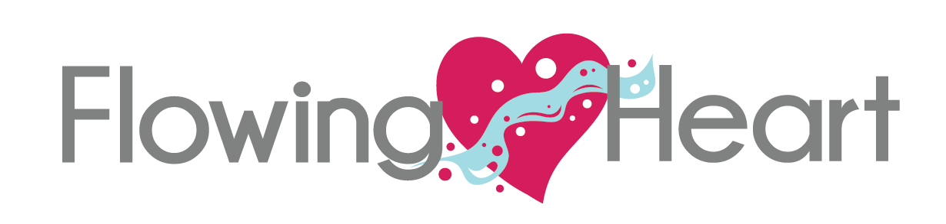
Reiki, Reflexology & Readings

Integrated Energy Therapy®
Basic & Pets
(A 2-day Combined Attunement & Certification)
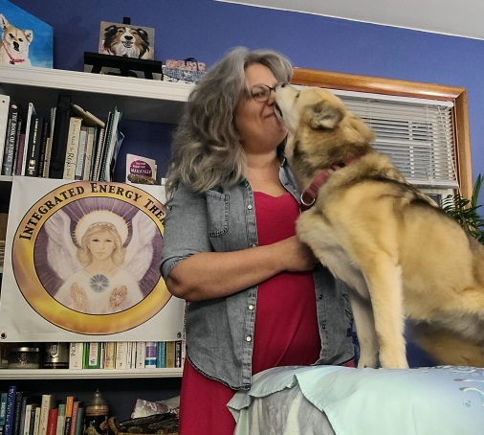
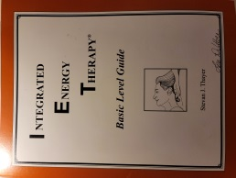
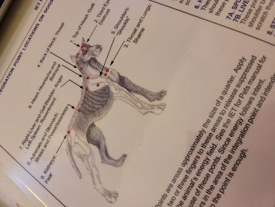

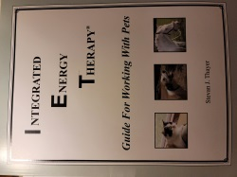

DATE: May 28th 10 am to 5 pm & May 29th 10 am to 3pm
PLACE: Reiki by Rickie ~ ReikiSpace and Learning Place
2793 Old Post Rd, Ste 10, Harrisburg, PA 17110
PRICE: $315 Register by May 21, 2022 at reikibyrickie.com
The objective of IET is to provide a simple and gentle way to open the flow of vital life force within the human body and the human energy field, by integrating suppressed feelings from cellular memory and clearing their associated blockages.
Integrated Energy Therapy Basic  In this class, even though it’s called ‘Basic Level’ you will receive everything you need to do a powerful Integrated Energy Therapy Session on yourself or on another person.  IET Basic works at the 1st (physical) and 2nd (emotional) pair of the 12 strand DNA and provides you with the ability to clear blockages from the cellular memory and imprint positive physical and emotional energy imprints. It helps get the ‘issues out of your tissues!’  This class has been designed to be a wonderful entry level class for those students wanting to use energy therapy to heal their lives, an ideal class for students wanting to begin an energy therapy practice, and it provides a wonderful compliment to other holistic techniques. | Integrated Energy Therapy for Pets  (Pre-requisite: IET Basic)  Our Pets class was developed for people with pets as well as people without pets who love animals. IET Pets Classes focus on using Integrated Energy Therapy energy and techniques to support pets (specifically cats, dogs and horses) in their wellness. You will learn about the soul’s nature for each of these pets, how their cellular memory functions, and how to apply Basic Level IET techniques to help clear energy blockages from the cellular memory of these wonderful creatures.

